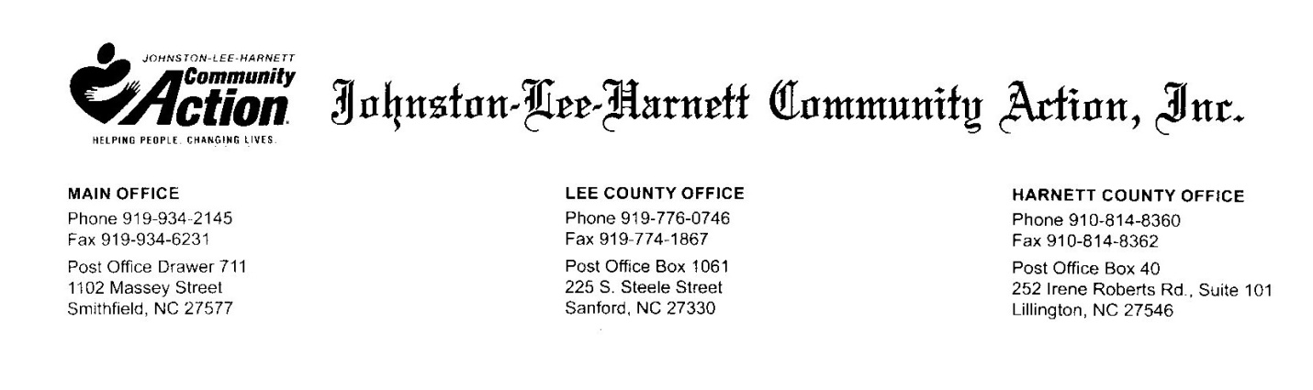

**CSBG Relief NC Program Guidelines**

Johnston-Lee-Harnett Community Action has received disaster relief funds called Relief NC. This program specifically targets individuals and families that have unmet needs as a result of **Hurricane Florence** that occurred in **2018**. The Relief NC Program at Johnston-Lee-Harnett Community Action will assist a limited number of eligible applicants with home repairs that meet the following guidelines:

1. Applicant must live in Harnett, Johnston or Lee County.
2. Relief NC funding shall not be available for costs that are reimbursed by the Federal Emergency Management Agency (FEMA), under a contract for insurance or by self-insurance. Funding is for non-duplication of FEMA assistance and non-duplication for life, health, automobile, homeowners, renters and property insurance.
3. Participants eligible for CSBG Relief NC assistance must self-certify and attest that proposed services and activities that they may receive were caused by Hurricane Florence. In addition, participants must attest that falsification or misrepresentation may result in the rejection of application and may be subject to prosecution under applicable State and Federal statutes.
4. Applicant must meet the federal poverty guidelines found below

|  |  |
| --- | --- |
| **2020 Poverty Guidelines for the 48 contiguous states & the District Of Columbia** | |
| **Persons in family/household** | **Poverty guideline** |
| **For families/households with more than 8 persons, add $8960 for each additional person.** | |
| **1** | **$25, 520** |
| **2** | **$34,480** |
| **3** | **$43,440** |
| **4** | **$52,400** |
| **5** | **$61,360** |
| **6** | **$70,320** |
| **7** | **$79,280** |
| **8** | **$88,240** |
| For each additional person add | $8,960 |